Feedback
Oleksandr Bondarev

Good:
- Game graphics is really nice.
- Putting bullet in separate class is a good design decision.

Improvement:
- It seems that your main class is overloaded with functions. What do you think about moving some functionality to any new helper class? For example – Forest.
- What do you think about putting bears to random location at the beginning of the game and after showing new bears? For example x = random(width), y = 0.

Bear Hunting Game
Pallavi Chourey

Bear Hunting is a shooting game that challenges players to play against the bears in the jungle to save himself. The illustration below shows the user interface of the game while it is running:

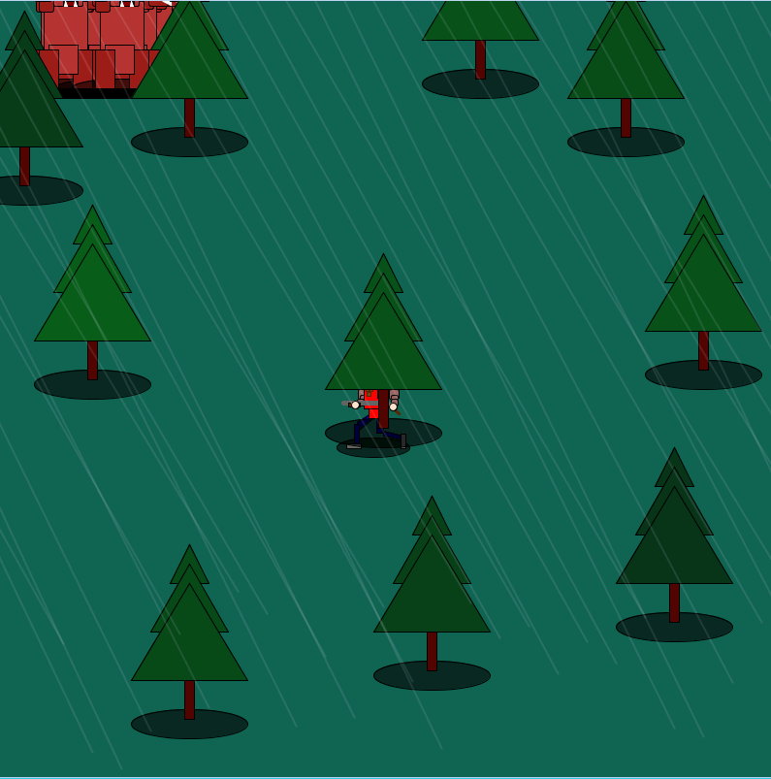

Here, the Man behind the tree in the center represents hunter and bears will enter the jungle from left side of the screen. Bears are moving and attacking on hunter as well. Hunter has the gun to shoot bear. I will be using keypressed to move the hunter. If bear attacks the hunter. Hunter is dead & the game ends. I am planning to add timer also.

How it Works
The functionality of the game is spread across a main processing loop and classes. See the descriptions of these classes below:

Bear Class
The purpose of the Bear class is to draw and display bears. It also contains the code for testing whether the catcher intersects with a drop. The Bear class describe its size and speed. The Catcher class contains the following methods:

void update()
This method is changing the speed & movement of bear.

display()
The display method is called to display the Bear object to the screen.

kill()
The kill method is for disappearance of bear from the screen if it is shot by the hunter. The code for the kill() method is shown below:

void kill(){ //teleporting bears upon getting hit with bullet
x= 2000;

}

float getX(){ //finding location
float t=x;
return t;
}

float getY(){
float rer = y;
return rer;
}
}

Bullet Class
The purpose of the Bullet class is to draw and control the movement of a bullet. All bullets are of same size and small dot in shape.
update()
This method decides the direction of bullet according to hunter’s walking direction.
display()
The display() method shows the bullet. A bullet is shown by

if (mousePressed){ //bullet coming back to lumberjack.
bullet();
}

}

float getX(){
float t=locX;
return t;
}

float getY(){
float rer = yy;
return rer;
}

}

Main Game Loop
The main processing loop initializes the window, creates the necessary game objects, and controls the logic and timing of the game. It contains the following functionality:

setup()
- Sets the window size to 800x800 pixels
- Creates Bears object from the Bear class
- Sets the speed and direction of bears.
- Sets loop for reappearance of bears.

draw()
- Draws and moves the bear,hunter & trees.
- Trying to add display in console also whenever bear is hit or hunter is killed . Also it will show the location of bear.
- When the hunter is killed by bears, displays “You are dead” at the end and we have to restart again to come back in the game. Following command is to show “You are dead”
if (death){
fill(255,0,0,210);
rect(0,0,800,800);
fill(0);
textSize(40);
text("You're dead.", 300,400);
if(keyPressed){
}if (key == ENTER){
reset();
}
}
- Keypressed function is used to determine the direction of hunter:-
void keyPressed(){

if(key == 'a'){
dirx = -5;

}
if(key == 'w'){
diry = -5;
}
if(key == 'd'){
dirx = 5;
}
if(key == 's'){
diry = 5;
}

}

**Timer class will be added once we have it covered in our class.
**Want to add sound effects also at the end.

